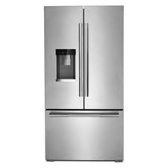

RISE™ 72

* 135V Low Voltage Startup
* Control & Child Lock
* Color Sliver
* French Door
* **Rs.91,783**